Alberto Martinez
CST 238
10/15/04

Comboling

The game Comboling was invented by Jerome Luling in the mid 80s while watching the tiles on the bathroom floor. The reason I think this would be a good program to make is because there is so much GUI involved. When playing this original version there were certain parts that I liked and disliked about it. It is a very fun game but I believe in a puzzler as hard as this there should be a track of the line that is made. Direction would be appropriate as well as marking the first square that is chosen. Also, I believe a neat little feature would be “stronger” squares that have to be hit twice or perhaps fixed-routes that the user must use. It would add replay value to the game. I would like to start adding features such as these if time permits.
Let me explain how the game is played. The user is confronted with a field of squares. Depending on the level, there will be squares which are highlighted or raised. The object of each level of the game is to push down or select all the tiles that are highlighted or raised. Here is the catch, after the first tile the user must select a tile that is in a straight line from the select tile. Straight line with the restraint of 8 directions; up, up-right, right, down-right… etc. A simple path is displayed below.

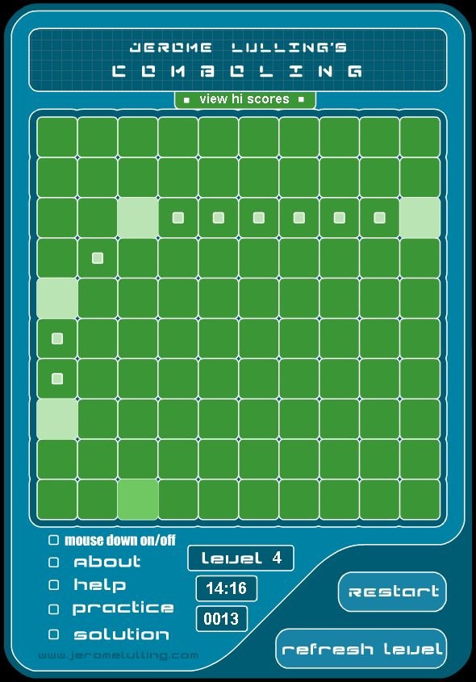

There will be two major challenges involved in the creation of this game. Programming the rules with an intuitive easy-to-use interface and setting up difficulty algorithmically. So far I have been able to see that each level has level + 1 tiles on the field. However I am unsure how placement is setup. The only thing in my mind as far as setting up a field is drawing the level amount of straight lines on the field at random and placing tiles at the line locations. Such an approach would easily provide a way of the user to give up and see the solution on the board. It would also allow for a help button which could flash the next suggested tile in the series.

Please let me know what you think of my idea.

